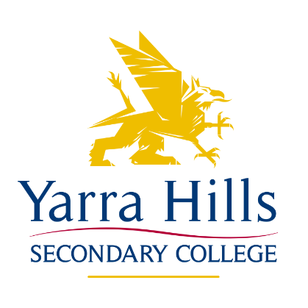

COLLEGE EXAMINATION POLICY

Purpose:
- To increase student outcomes/ performance in examinations
- To increase student work ethic and motivation in preparation for, and approach to, examinations
- To establish consistent examination procedures across all campuses
- To effectively prepare Yarra Hills students for examinations

Proposal:
That all students from Year 10 - Year 12 sit examinations;
- Semester 1;
  - Unit 1 & 2: All subjects
  - Year 10: All core subjects

- Semester 2:
  - Unit 3 & 4: All subjects (Term 3 practice exams)
  - Unit 1 & 2: All subjects
  - Year 10: All core subjects

Implementation:
- Examination to be a structured response to key knowledge and skills learnt in given subject throughout semester.
- A revision period should occur prior to examination in order to effectively prepare students for prescribed content.
- Staff should work collaboratively across subjects and KLA’s to develop consistent examinations.
- All exams should reflect the exam structure of VCAA exams where possible.

Students with additional needs:
- Accommodation: It is the responsibility of the classroom teacher to arrange, in collaboration with the Integration Coordinator and/or Well-being Coordinator, for any accommodation a student may be entitled to.
- Modification: It is the responsibility of the classroom teacher to arrange for the production of modified examinations for students on a modified program.
- The exam needs to be appropriate to the program that has been delivered in class according to the recommendations of individual student’s educational assessments.

Environment:
- Students will complete all examinations in a formal examination room and not the students’ own classroom, wherever possible.
- Staffing allocations during exam period should avoid staff being present in their own subject examination.
- Staff should avoid answering questions during the exam pertaining to specific subject content, thus guiding student responses.
- Staff will enforce the rules governing examination conditions for students

Accountability:
- The examination will appear on the Semester Report as a separate item and reported upon as a percentage overall.
- Should a student fail both examinations over two semesters in a Year 10 subject, that student would be required to demonstrate their ability in that subject if they wish to undertake that subject as part of their VCE the following year.
- The exam marks will be used to rank students and this ranking will be used to help determine entry into the following year’s VCE subject.

This Policy was ratified by School Council on
and is due to be reviewed in 2022

