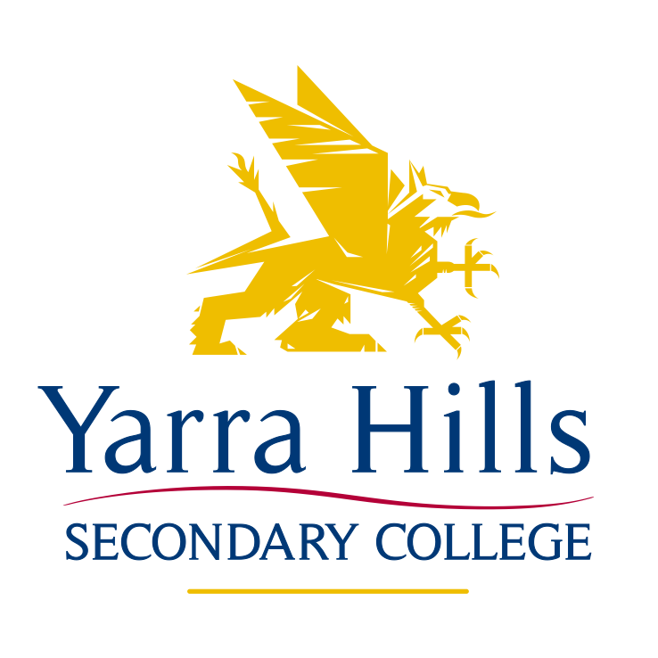

Head Lice Policy

Rationale

Yarra Hills Secondary College acknowledges the fact that from time to time students may experience head lice. Whilst parents have the prime responsibility for the detection and treatment of head lice, Yarra Hills has a role to play in management of head lice infections and providing support for parents/guardians and students. It is important to provide clear processes and accurate information for when the occasion arises to ensure student absences are kept to a minimum and the spread of head lice is contained.

Aim

To prevent the spread of infestation of Head Lice and provide up to date information for parents. This policy also aims to put the right protocols in place when alerted to the incidence of head lice amongst students or staff.

Responsibilities:

The school will:
- Provide up to date information through the newsletter and Compass including information for detection, treatment and control of Head Lice. Further information is available from: http://www.health.vic.gov.au/headlice/
- Alert families in the event we become aware that head lice is within the school.
- Maintain confidentiality with the affected student/s to reduce any form of stigma towards the student/s.
- Encourage students to learn about head lice in Health classes.
- Contact parents if students are identified with head lice and be separated due to the highly contagious nature of the parasite.

Parents will:
- Regularly check their child’s head for head lice.
- Refrain from sending their child to school if they are aware their child has head lice.
- Treat their child’s head lice and continue treating until the eggs are completely removed. One treatment is often not enough to treat the eggs.
- Ensure students do not return to school until the head lice is treated and the eggs are removed.
- Notify the school if their child comes home with head lice and advise when treatment has commenced.
- Will collect students who have been identified with head lice.

Ratified by School Council November 2017

