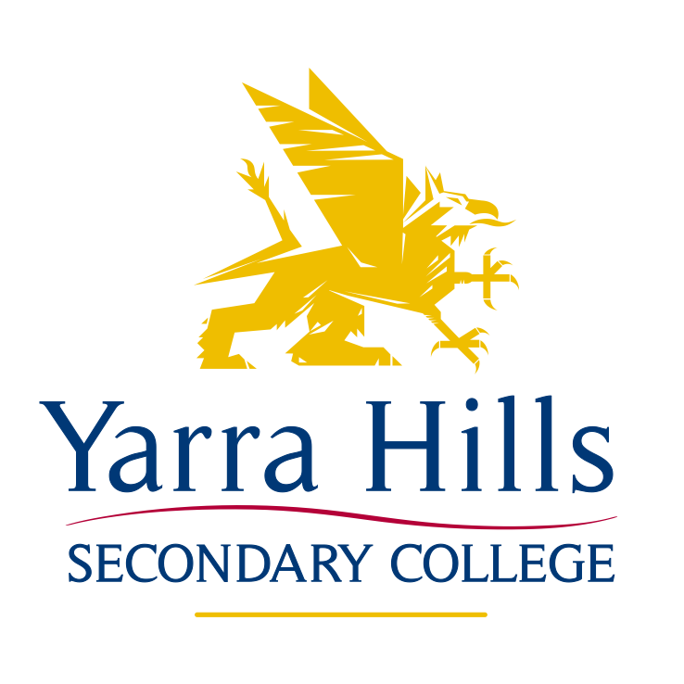

Gender Equity Policy

RATIONALE
Yarra Hills Secondary College is committed to creating a school community where all staff and students are equally respected and valued and enjoy equity of opportunity, outcomes and safety. Yarra Hills Secondary College recognises that gender inequality has the potential to limit and impact negatively on the safety, education, employment, family lives and opportunities of staff and students, in the immediate and long term.

Under the Equal Opportunity Act 2010 all organisations have a duty to take proactive steps to prevent discriminatory practices Yarra Hills Secondary College recognises in both staff and students, the prevalence and impact of gender-based discrimination and harassment, and is committed to building a school culture that challenges the stereotypes, power differences and social norms that foster gender inequity. Yarra Hills Secondary College recognises that gender inequality is both structural and individual; this means it is not only the result of individual attitudes and actions, but also of biases in structures, systems, policies and processes throughout our community.

Girls and boys, men and women are subject to gendered stereotypes and expectations about how they should behave, think and act. These gendered stereotypes and expectations contribute to gender inequality by assigning unequal value, status and power to men and women.

Gender equity refers to fairness and justice in the distribution of rights, responsibilities and resources between women and men according to their respective needs including gender identity. Behaviour is affected by the culture and environment in which it occurs. To promote gender equity it is important to recognise the way that gender stereotypes can influence what is seen as acceptable behaviour and the impact this can have on both student behaviour and the ways behaviour is managed.

Gender inequality can be both a cause and a consequence of direct and indirect discrimination. This discrimination is sometimes the result of unconscious bias which is when our behaviours, choices and practices are shaped by underlying assumptions and attitudes without us realising. Gender inequality is evident throughout our society, and research suggests it is one of the key factors that drive the prevalence of family violence.

Yarra Hills Secondary College will ensure that all students, staff, school policies, procedures, systems and structures actively promote gender equality. We also seek to expose and redress gender inequities in our school culture and environment. Students and staff are responsible for promoting gender equity and modelling respectful relationships. All staff and students will be held accountable if they use language and/or demonstrate behaviour that:

- Promotes unequal power relations between men and women.
- Perpetuates harmful gender stereotypes.
- Condones violence against women, men and children.

Promoting gender equity and modelling respectful relationships is important for staff as well as students. Yarra Hills Secondary College will work to ensure all staff feel respected, safe and valued in the workplace. The school will take proactive measures to prevent and eliminate gender discrimination and provide equal opportunities for all staff. This will include promoting gender equity in school leadership, ensuring processes and policies and processes are free of bias, and supporting all staff to balance work and family commitments. Yarra Hills Secondary College will also ensure hiring practices reflect gender equity according to the Equal Opportunity Act 2010.

Yarra Hills Secondary College will support staff that experience domestic/family violence or sexual assault by:
- Making reasonable efforts to grant appropriate leave.
- Adjusting work assignments.
- Or accommodate requests for flexible work hours.
Students who experience domestic or family violence will have access to the appropriate support. This will include the Wellbeing team, Year Level Coordinator and/or the Campus Principal. See Mandatory Policy for further information.

Teaching and Learning
Yarra Hills Secondary College is committed to supporting all staff:
- To fulfil their obligations under the Equal Opportunity Act 2010.
- By providing the necessary professional development to fulfil these obligations.
- By explicitly promoting gender equality in their teaching practices within their engagement of students both in and outside the classroom.

Yarra Hills Secondary College will also ensure adequate support and professional development is provided to staff across various key learning areas to select, review and deliver curriculum that:

- Represents the range of experience, knowledge, skills and aspirations of girls and women, boys and men.
- Provides opportunities for students to understand, identify and challenge gender inequality, harassment, discrimination, gender stereotypes and violence against women, men and children.
- Gender dysphoria and gender identity issues

Yarra Hills Secondary College behaviour management framework:
- Clearly sets out and models expected behaviours for students and staff.
- Recognises how gendered social dynamics and norms can influence student behaviour.
- Gives staff tools to engage student(s) in challenging gender stereotypes.
- Gives staff tools to identify and respond to dominating or disruptive behaviours so they do not inhibit the learning of other students.

Responsibilities
The principal is accountable for implementation of this policy. All members of the school community have a responsibility to respect and promote the rights of others. Yarra Hills Secondary College encourages all members of the school community to take appropriate bystander action to intervene safely and respectfully when they see or hear about sexist language, sex discrimination, sexual harassment or a potentially violent situation within the school community.
Any member of the school community who raises an issue of gender inequity will not be victimised or otherwise unfairly treated or disadvantaged. All complaints of victimisation will be taken seriously, investigated and acted upon as quickly as possible.

Relevant Policies and Guidance
- Well-being Policy
- Code of Conduct
- Bullying and Harassment Policy
- Mobile Phone Policy
- On-site supervision
- Duty of Care Policy
- Mandatory Reporting Policy

For further information:
Victorian Equal Opportunity and Human Rights Commission, Positive duty: Know your responsibilities (2011)
http://www.humanrightscommission.vic.gov.au/index.php/our-resources-and-publications/know-your-responsibilities-brochures/item/133-positiveduty-know-your-responsibilities-aug-2011).

VicHealth, Preventing violence against women: A framework for action (2009)
https://www.vichealth.vic.gov.au/media-andresources/publications/preventing-violence-before-it-occurs

World Health Organisation, Preventing intimate partner and sexual violence against women: taking action and generating evidence (2010)
http://whqlibdoc.who.int/publications/2010/9789241564007_eng.pdf)

Department of Education and Training – School Policy and Advisory Guide: Gender Identity
http://www.education.vic.gov.au/school/principals/spag/health/Pages/genderidentity.aspx

Ratified by School Council October 2016

