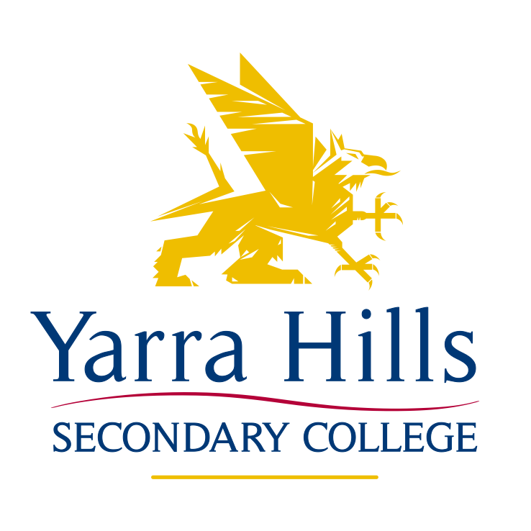

SPORT POLICY

Rationale

Sport is part of, and a logical extension of, all the components of a comprehensive Physical and Sport Education program. The College Sports program at Yarra Hills Secondary College aims to provide a dynamic foundation for life long physical activity choices and preparation for an active healthy lifestyle. It involves both inter and intra-school sport and is concerned with the development of the performer, official and spectator in relation to their knowledge, skills, attitude and values in a wide range of both competitive and non-competitive sporting and recreational pursuits. The College Sports program is an inclusive program that emphasises broad participation, fun, improvement and the achievement of one's personal best.

Administrative guidelines

- The Sport program and its proposed dates must be approved by the Consultative Committee in Term 4 of the previous year.
- A Sport Coordinator should be appointed at each of the 2 campuses (2 x Junior and 1 x Senior) with appropriate time allocated as deemed necessary. The College Sport Coordinator will be based at one of the campuses and will be responsible for Sport at that campus in addition to the overall College Sport delivery.
- The College shall provide an adequate budget for Sport that allows for - purchase of necessary equipment, uniforms, bus hire and affiliation fees, to enable effective functioning of the program.
- Those who are responsible for a sport event shall maximise the use of school resources (ie. CRT extras). Resources are to be used as efficiently as possible in the operation of the program.

College and Campus Sport Coordinators

The College and Campus Sport Coordinator/s will:
- Ensure that all activities where classes need to be covered or students are taken from another class have an application created as an Event on Compass.
Staff guide for compass events camp & excursion/incursion guidelines must be consulted for planning of all sporting events.
- Provide educational leadership in the development, implementation, evaluation and organisation of an inclusive Sport program within state wide policies and guidelines.
- Coordinate Sport for the entire College student and staff population.
- Organise an Intra-College House system of Sport that includes the following whole College Carnivals: - Swimming (1 day) early Term 1, Athletics (1 day) early Term 2, and Cross Country (½ day) Term 2. These times are weather dependant.
- Liaise with and encourage staff, parents, senior student leaders and members of community sporting bodies to train and coach our Summer and Winter Round Robin teams; strengthening community links and easing the repercussions of staff only involvement.
- Oversee the training of Round Robin teams, prepare kits and launder uniforms.
- Attend Lilydale/Yarra Group Sport meetings and convene Group Carnivals and Round Robins as necessary.
- Monitor Sport Calendar development to ensure rotated event days in an attempt to lessen the impact on specific classes that students may miss through Sport involvement.
- Inform staff and students that involvement in Sport for students is not an automatic right but has to be earned through commitment, training, good behaviour and appropriate work ethic in classes that may be missed through Sport involvement. Issues relating to students being withdrawn from sporting teams must be referred to the Year Level Coordinator.
- Place all students and staff in House Teams either linked to Roll Call/Form Groups or randomly selected with attempted age group and gender balance.
- Organise the House Captain/Student Leadership aspect of the Sport Program including selection and training so that active student leaders play a significant role in House meetings, carnival organisation and officiating and Round Robin Team coaching.
- Ensure that Sports teams representing the College have student captains and vice-captains elected so that appropriate positive feedback can consistently occur through newsletters, assemblies, end of year magazines, local newspapers and government sports awards schemes.
- Advertise early and hold regular House meetings to allow adequate organisation of teams prior to Carnivals and the creation of genuine House Spirit through awards to house members.
- Utilise Gymnasium duty staff and sport captains in the training of teams, the use of gymnasiums, the use of sports equipment and the development of lunchtime activities programs.
- Promote and publicise all sport related opportunities that come to attention from the wider community, again to strengthen links in the hope that lifelong, active participation is an outcome.
- Develop strategies to encourage and increase the participation of students with special needs in sport.
- Strengthen the sporting ties between the 2 campuses including sharing resources, conducting inter-campus competitions and creating stronger single college teams where appropriate.
- Ensure that all students are wearing the correct Sport/PE uniform at all times when representing the school. If students fail to bring the required materials their involvement could be jeopardised. This must include appropriate sports shoes (Please refer to the College Sports Uniform Outline)

Ratified by School Council June 2016

