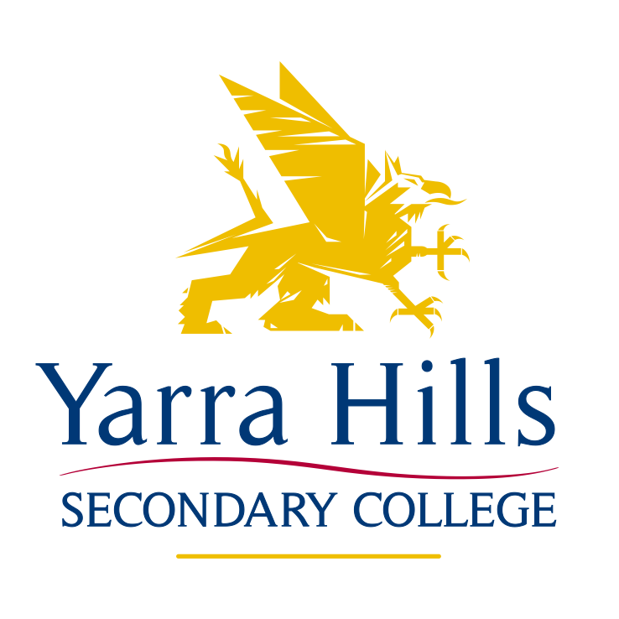

VCAL Selection Policy

RATIONALE
Yarra Hills Secondary College offers VCAL (Victorian Certificate of Applied Learning) as an alternative educational pathway for students in the Senior School. VCAL is a hands-on option for students seeking practical, work-related experience. VCAL involves work-related literacy and numeracy, as well as personal skills that are important for life and work. VCAL students attend two days of on-site schooling at Yarra Hills, one day of TAFE (or equivalent) and up to two days of work placement (School Based Apprenticeship Training). This VCAL policy has been developed to ensure that all students who select this pathway are fully aware of the educational and workplace selection pre-requisites, as well as administrative and financial requirements for ongoing involvement in the program.

PATHWAYS PLANNING AND THE VCAL

Students who plan to enrol in the VCAL program should note the following important points:
- The VCAL does not provide students with an ATAR score and is not a course for students who wish to go on to University
- The VCAL is appropriate for students whose career path after school includes entry to TAFE, Apprenticeships or Employment
- VCAL tasks are recorded as S or N when students meet each Unit’s outcomes. There is no graded assessment in the VCAL
- VCAL students spend 2 days at school, in class; 2 days per week with an employer working towards their School Based Apprenticeship [SBAT] and 1 day per week in a TAFE course.

VCAL CHECKLIST

Students who think that VCAL is the best course for their future pathway should address the following checklist. If their answer to all of these questions is ‘yes’, they should discuss the VCAL in more detail with their parents and the Pathways and/or VCAL Coordinator

Checklist questions:
• Do I work better when I am involved in practical tasks rather than academic work?
• Does my career path involve TAFE, an apprenticeship or employment, but not University?
• Am I prepared to travel to TAFE to study the course that meets my needs?
• Do I agree to pay my atEAST and TAFE fees prior to course commencement?
• Do I understand that it is my responsibility to find employment in certain industries?
• Am I prepared to travel outside of the Outer Eastern area to attend my TAFE and job placement?

Reference: http://www.vcaa.vic.edu.au/

CONDITIONS OF ENTRY INTO VCAL

Any student wishing to complete a VCAL program must satisfy the following conditions:

If a student joins the program by the end of Year 10:
- Students must have completed 2 separate Work Experience placements with different employers in their chosen field.
- Students should have at least a level 9 in the Numeracy and Literacy domains based on the AusVels levels.
- Course numbers are capped at one class at Year 11 [no more than 20 students] and one class at Year 12 [no more than 20 students] until/unless sufficient numbers arise to justify a complete additional class. (For example: this may arise if employer recruitment occurs when students are signed up in October and most students are then employed for access to the program)
- If a student wishes to complete their SBAT in any of the following industries, enrolment into VCAL will not be accepted unless the student is signed up with an employer by the end of their Year 10 year. (i.e. you must bring a guaranteed placement with you)
- Animal
- Beauty
- Electrical
- Diesel Mechanic
Please note: It is the student’s responsibility to find employment in these industries and these ‘restricted’ industries will change from year to year.

- A weekly report will be provided by atEAST that will provide information on the progress of recruitment for students from Oct-Dec of their Year 10 year. [Intense recruitment should occur at this stage and students will also pursue their own employment]- Consult with atEAST regarding this.
- Students will attend a formal interview with atEAST which will determine their suitability and acceptance in to the program

If a student wishes to enter the VCAL program after the commencement of the school year:
- They must bring a job to their SBAT otherwise they will not be eligible to enter the program.

If a student wishes to enter the VCAL program in a ‘non-supported’ industry and/or does not have a guaranteed work placement by the end of February in their 1st VCAL year:

- They must enrol and begin attendance in a regular VCE course at the College
- If they secure a position, their possible ‘late’ acceptance into the program will be based on:
-Space(s) available in the VCAL classes (if no spaces left, then they cannot join VCAL)
-Completion of all appropriate administrative requirements, including ALL paperwork and VCAL course fees.

If a student wishes to enter the VCAL program after the standard Year 11 commencement (ie: complete a Year 12 VCAL year only):
- They must negotiate their possible placement into a VCAL program with the Pathways Leader.

Please direct any queries/questions to the Pathways/VCAL Coordinator.

Ratified by School Council 18/08/2015.

